**CSC 335 Data Communications and Network I**

**Homework 4**

1. (1 point) What is multiplexing? Differentiate between frequency and time division multiplexing. What are three important link layer services? Explain the problem of channel access (medium access control).

Multiplexing is the being able to send multiple signals simultaneously on the same medium. Frequency division multiplexing differentiates between signals based on their different frequencies, whereas time division multiplexing differentiates between signals by synchronously alternating which signal appears on the line so that each signal travels in its allocated time slot to be filtered to the correct receiver on the other end.

Three important link layer services are the framing –adds the header, trailer, and addressing for the link layer, channel access – controls who uses the channel and routing/reception of data, and error detection – requests sender for retransmission or drops frame if an error is detected. The problem of channel access is that if two or more simultaneous transmissions by nodes occur, it will result in severe “interference,” also known as a collision (no parties involved in the collision will receive the correct signal).



1. (2 points) Consider the generator polynomial *g*(*x*) = 1 + *x* + *x*2 + *x*4. Encode the message bits 010 into a 7-bit codeword. Show that the remainder is zero if this codeword is received correctly.

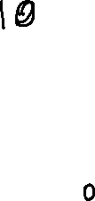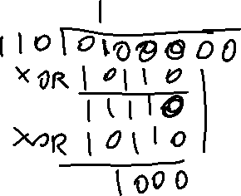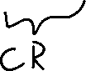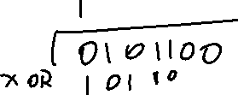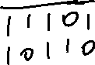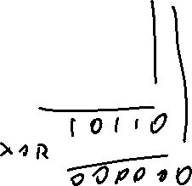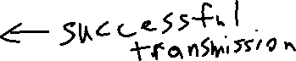

1. (2 points) If the received 7-bit word for the coding scheme from Problem 2 is 1 1 0 0 1 0 0, what is the remainder?

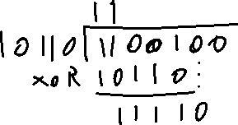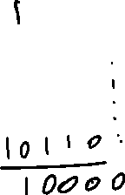

1. (1 point) Classify medium access control protocols.

The three types of MAC protocols are channel partitioning, random access, and “taking turns.” Channel partitioning means dividing the channel into smaller “pieces,” whether its by time slots or by different frequencies. Random access is self-explanatory – as a machine wants to access the channel, it simply sends its data across the channel (which can result in collisions if different machines try to use the channel at the same time). “Taking turns” works on a first come-first serve basis, but lines up the requests to use the channel so that collisions do not occur.